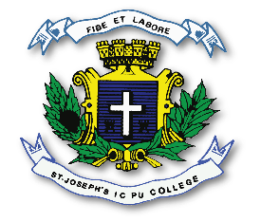
ST. JOSEPH’S INDIAN COMPOSITE PU COLLEGE
#23, Vittal Mallya Road, Bengaluru – 560001
SUBJECT: BIOLOGY (36)
CLASS – I PUC
PORTIONS FOR MID TERM EXAMINATION – SEP / OCT 2026
Chapter 1 – The Living World
Chapter 2 – Biological Classification
Chapter 3 – Plant Kingdom
Chapter 4 – Animal Kingdom
Chapter 5 – Morphology Of Flowering Plants
Chapter 6 – Anatomy of Flowering Plants
Chapter 7 – Structural Organization in Animals
Chapter 8 – Cell: The Unit of Life
Chapter 9 – Biomolecules
Chapter 10 – Cell Cycle and Cell Division

ST. JOSEPH’S INDIAN COMPOSITE PU COLLEGE
#23, Vittal Mallya Road, Bengaluru – 560001
SUBJECT: BIOLOGY (36)
CLASS – II PUC
PORTIONS FOR MID TERM EXAMINATION – SEP / OCT 2026
Chapter 1 – Sexual Reproduction in Flowering Plants
Chapter 2 – Human Reproduction
Chapter 3 – Reproductive Health
Chapter 4 – Principles Of Inheritance and Variation
Chapter 5 – Molecular Basis of Inheritance
Chapter 6 – Evolution

