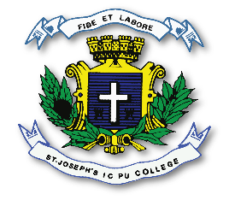
ST. JOSEPH’S INDIAN COMPOSITE PU COLLEGE
#23, Vittal Mallya Road, Bangalore – 560001.

SUBJECT- SOCIOLOGY (28)
I PUC
PORTION FOR MID TERM – SEPTRMBER (2026-2027)

CHAPTER 1 NATURE OF SOCIOLOGY
CHAPTER 2 BASIC CONCEPTS
CHAPTER 3 SOCIAL PROCESS
CHAPTER 4 CULTURE AND SOCIALIZATION

DEPARTMENT OF HUMANITIES
SARITHA ROSHAN

